PlatformIO Set Default Directory

/home/tractor/catkin_ws/project_support_files/embedded_programs

pio settings set projects_dir THE NEW PATH

$ pio settings set projects_dir /home/tractor/catkin_ws/project_support_files/embedded_programs

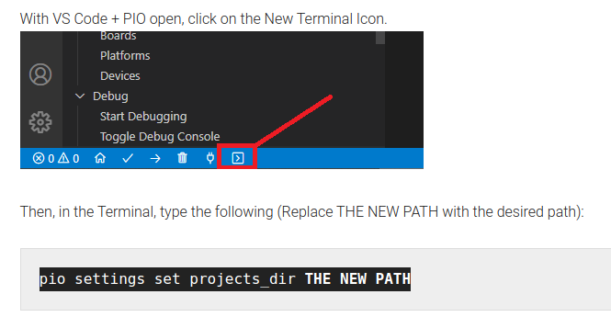

pio settings set projects_dir /home/tractor/catkin_ws/project_support_files/embedded_programs/tractor_control_2022

